A000-**Eur-Germany-Vogelherdhöhle-Figurine-***Panthera leo spelaea***-Ivory-Middle Paleolithic-**40,000 BP

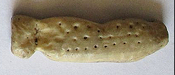 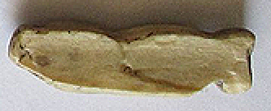

Fig. 1-2. **Germany-Vogelherdhöhle-Figurine-***Panthera leo spelaea***-Ivory-Middle Paleolithic-**40,000 BP-29,000 BP, recto and verso, replica.

**Formal Label: Germany-Vogelherdhöhle-Figurine-***Panthera leo spelaea***-Ivory-Middle Paleolithic-**40,000 BP-29,000 BP

**Display description:**

**This ivory** *Panthera leo spelaea,* or Eurasian Cave Lion, **mammoth ivory figurine dating** 40,000 BP-29,000 BP, **exhibits the shape of a lion with a lion’s pointed ears and appears dismembered without legs. Its pelt is spotted, which is new information for this species. In this respect it exhibits the intent of the artist to represent reality, being less of a symbolic interpretation. It conforms to the general shape of the** *Panthera leo spelaea* **in Lascaux:**

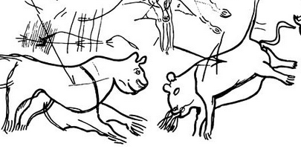

 **cm**

**Fig.** *Panthera leo spelaea,* Lascaux Cave, Dordogne, France, from Leroi-Gourhan and Allain 1979.

Vogelherdhöhle (“Bird Heart Cave”) was probably named for its location above the Lone River in its ability for attracting birds and its heart-like structure, since it has three cave chambers like a heart. It is among the most significant German Paleolithic sites. It is located on a sloping limestone ledge 20 m above the Lone River Valley over which it possessed a strategic view for hunters of Pleistocene game.

**Accession Number:**

**LC Classification:** GN772.2.A8

**Date or Time Horizon:** 40,000 BP-29,000 BP

**Geographical Area: Vogelherdhöhle Site, Germany**

**Map, GPS Coordinates:** 48.561321, 10.189116

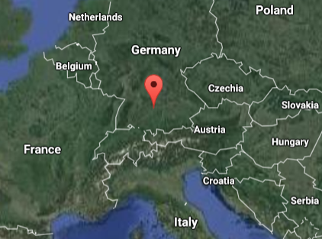

Fig. 2. Location of Vogelherdhöhle in the local landscape.

Fig. 3. Location of Vogelherdhöhle in Germany.

**Cultural Affiliation:** Aurignacian

**Medium:** original, mammoth ivory; museum replica in resin.

**Dimensions:   
Weight:**

**Provenance: University of Tübingen.**

**Condition:** museum replica in resin**.**

**Discussion:**

On 23 May 1931 Hermann Mohn, a private researcher from Heidenheim, while probing the hills near Stetten bei Niederstotzingen for prehistoric remains, found flint artifacts in the rear of a badger den. He informed the prehistory department of the University of Tübingen of a potential Paleolithic cave, which he named ‘Mohnloch’ or Mohn’s hole.’ The Tübingen department, unimpressed, sent a junior researcher, Gustav Riek, to Stetten to inspect the site. The Y-shaped cave has three openings (S, SW and N) and covers 170 m2. Mohn and Riek squeezed through the 30 cm x 40 cm opening into the badger den and on the evening of the second day they found the Paleolithic evidence they were looking for: Mohn’s hunch was right, this was confirmed and the site was renamed “Vogelherdhöhle,” “Bird Heart Cave,” probably for the waters of the Lone River attracting birds and the cave’s three chambers like a heart. Then, in just three months, Riek had excavated the cave, with large back-fill mounds looming outside the three entrances still holding artifacts yet to be discovered but now without any context. In the intervening years these mounds have been thoroughly re-examined and many artifacts have been recovered.

There are four Middle Paleolithic strata and four Upper Paleolithic strata of Vogelherdhöhle of which two of the latter, layers V and VI belong to the Aurignacian, which are the cultural strata for which Vogelherdhöhle is famous and in which the present artifact was found. (The Magdalenian is represented in two layers, the Gravettian is not present --as in almost all the cave sites of Lone River Valley--and the Neolithic affords the final evidence of human presence.)

Eleven mammoth-ivory figurines were excavated by Reik. The lower Aurignacian layer V supplied a total of seven, including *Panthera leo spelaea* or Eurasian Cave Lion, a horse, a mammoth, the rear part and the front leg and neck area of a large mammoth figurine, a headless animal figurine and an unidentified animal figurine with a reattached head from the excavations in 2012 (Conard et al., 2013). Four figurines from the upper layer IV include a *Panthera leo spelaea*, the present *Bison priscus or* steppe bison, a mammoth and an anthropomorph. Although the layer in which each figurine was excavated is known, Riek gave no indication of their exact positions and their contexts.

**References:**

Bosinski, G. 2013. “Les precurseurs de l'art aurignacien.” In P. Bodu, L. Chehmana, L Klaric, L. Mevel, S. Soriano and N. Teyssandier, N. (eds.), *Le Paleolithique superieur ancien de /'Europe du Nord-Ouest: Reflexions et syntheses a partir d'un projet collectif de* *récherche sur le centre et le sud du Bassin parisien: Actes du colloque de Sens (15-18 avril 2009)* Paris: Sociéte préhistorique française.

Conard, N. J., Zeidi, M. and Bega, J. 2013. “Die letzte Kampagne *der* Nachgrabungen am Vogelherd,” *Archaologische Ausgrabungen in Baden-Wurttemberg,* 2012: 84-88.

Delporte, H. 1990. *L'image des animaux dans l'art préhistorique,* Paris: Picard.

Delporte, H.. 1993. *L'image de la femme dans l'art préhistorique. Nouvelle edition augmentée,* Paris, Picard.

Hahn, J. 1970. “Die Stellung der mannlichen Elfenbeinstatuette aus dem Höhlenstein-Stadel in der jungpaläolithischen Kunst,” *Germania,* 48: 1-12.

Hahn, J., Muller-Beck, H. and Taute, W. 1985. *Eiszeithöhlen im Lonetal.* Stuttgart: Konrad Theiss Verlag.

Leroi-Gourhan Arl. and Allain J., eds. 1979. *Lascaux inconnu.* Paris: CNRS éditions.

Niven, Laura. 2006. The Palaeolithic Occupation of Vogelherd Cave: Implications for the Subsistence Behavior of Late Neanderthals and Early Modern Humans. Tübingen: Kerns.

Riek, Gustav. 1934. *Die Eiszeitjägerstation am Vogelherd im Lonetal*, Bd. I: Die Kulturen. Leipzig: Kabitzsch.

Riek, Gustav. 1935. *Kulturbilder aus der Altsteinzeit Württembergs*. Tübingen: Franz F. Heine.